|  |  |
| --- | --- |
| Course Name | ITD 2313 – Script Programming |
| Instructor | Mr. Pranger |
| Student Name | Trey Mobley |
| Due date | 05/10/2021 |
| Grade | <grade earned here> |
| Grading Comments | <instructor comments here> |

Page 42

1,2,3

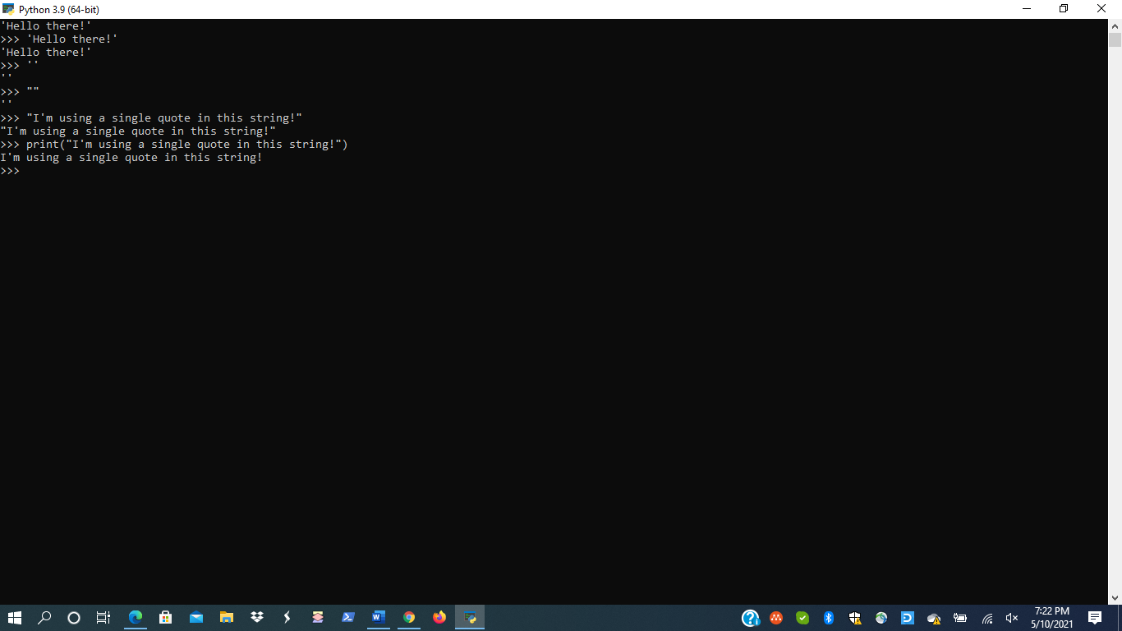

Page 43

1,2,3

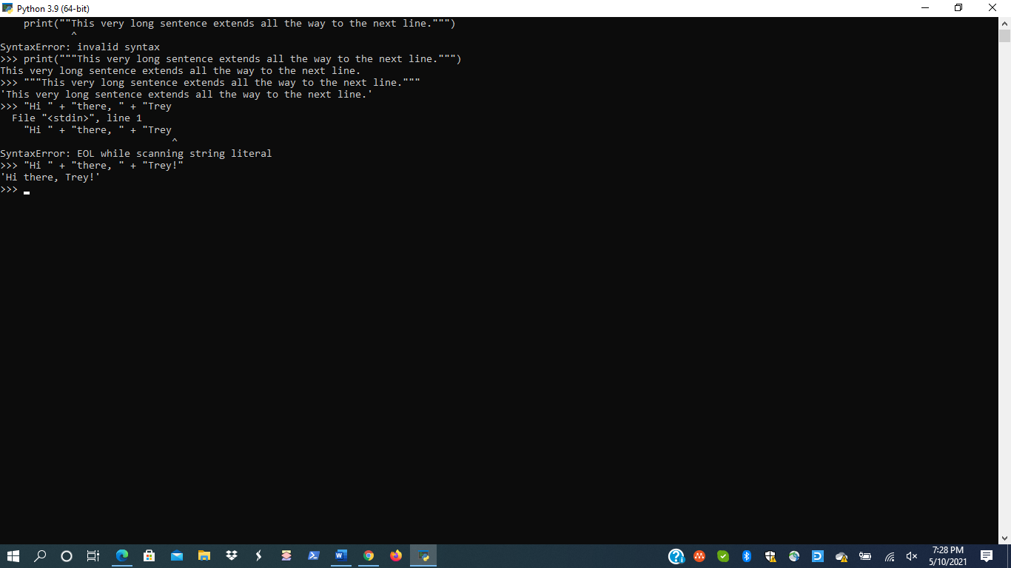

Page 44

1

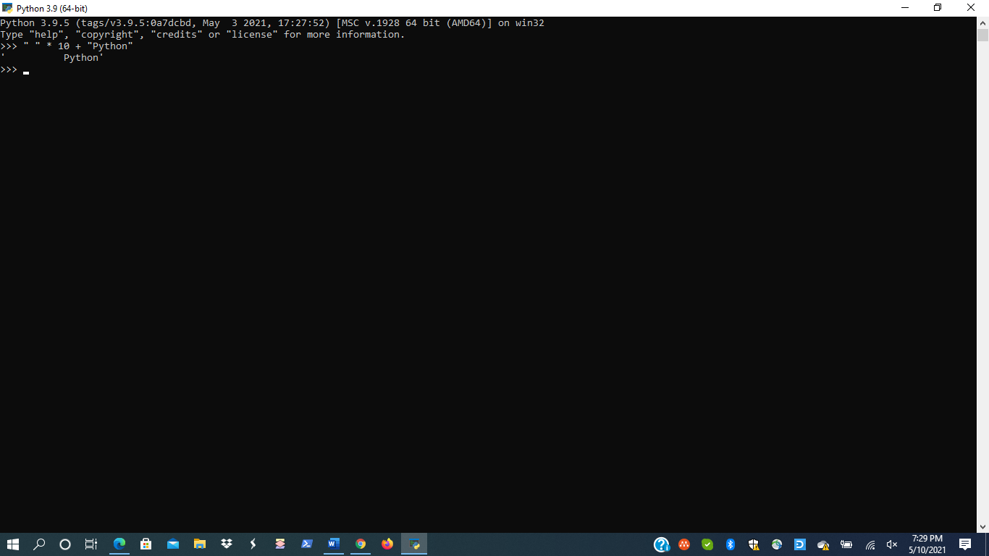

Page 45

1,2,3

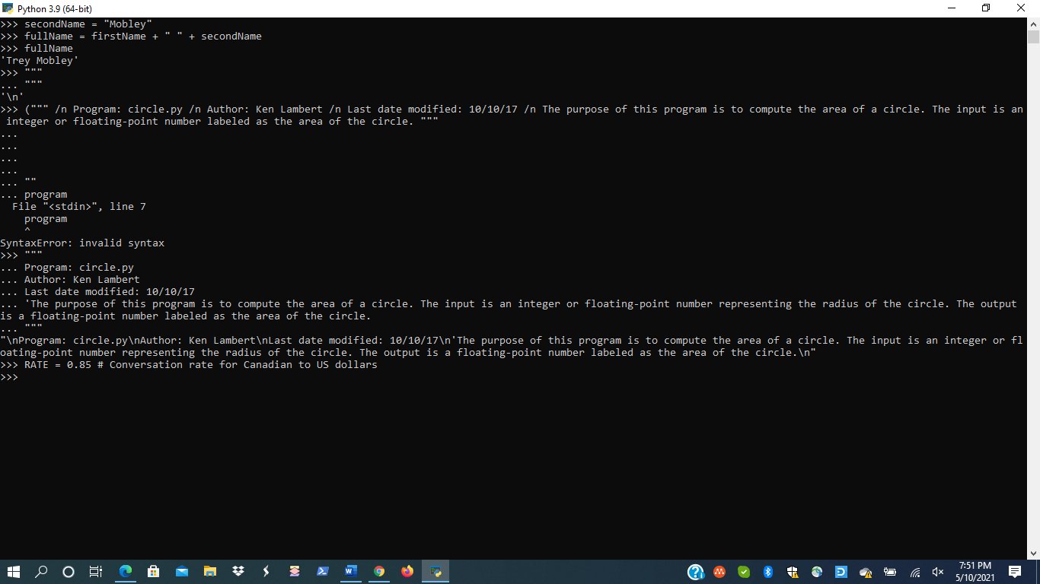

Page 49

1

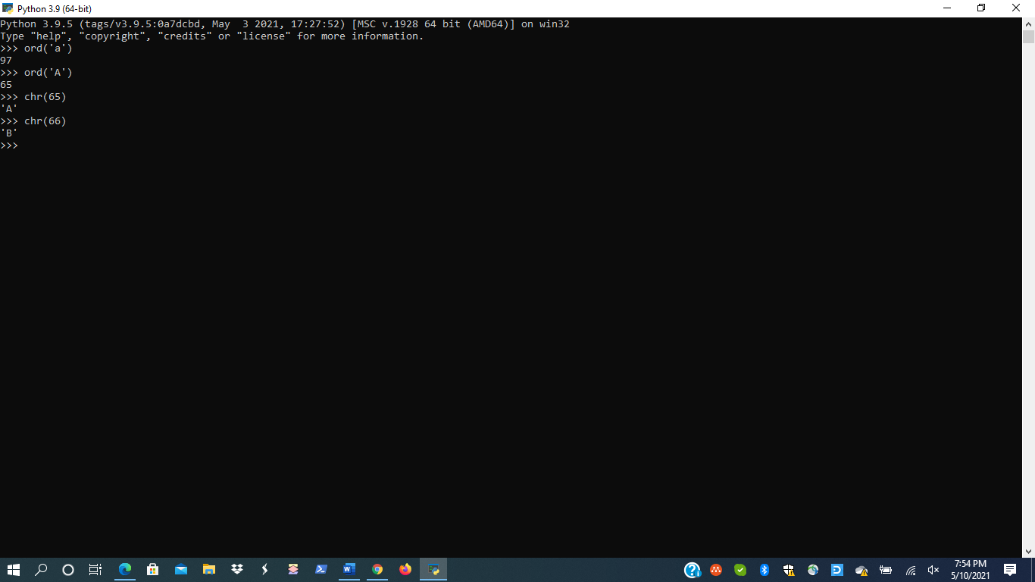

Page 51

1

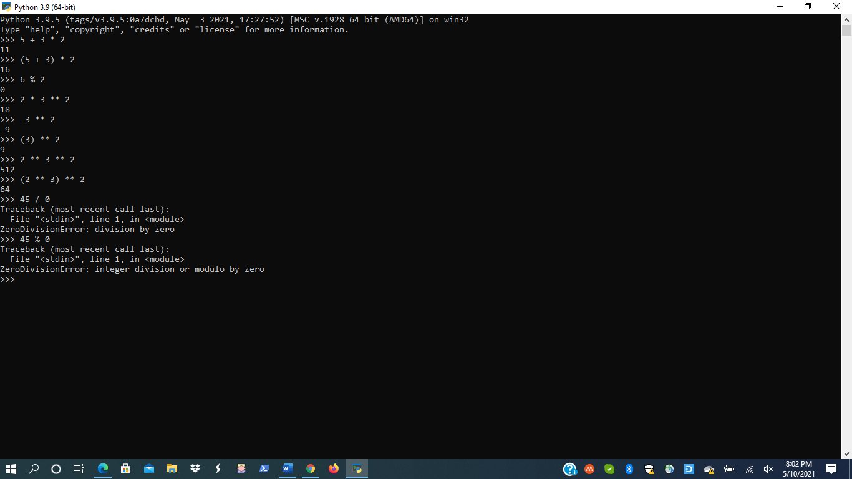

Page 52

1,2,3,4

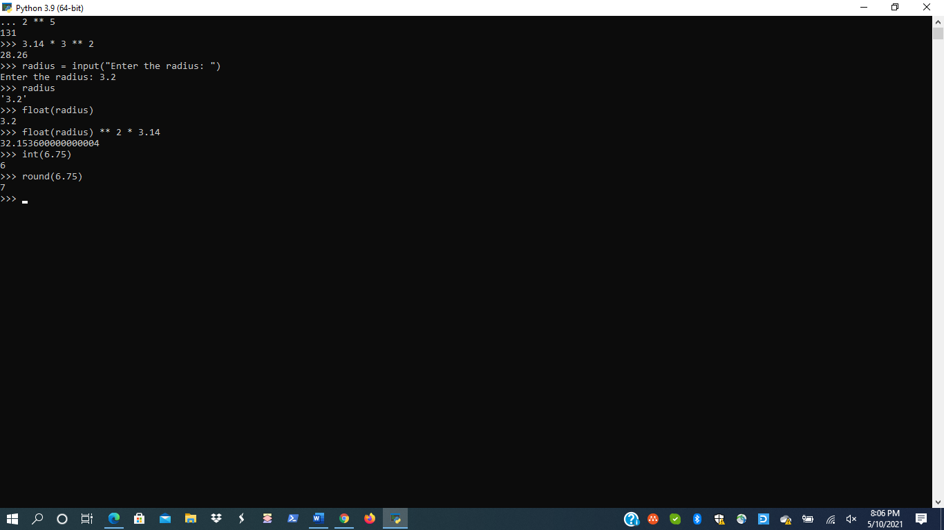

Page 53

1,2

